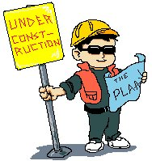

CAUTION:

CONSTRUCTION

AHEAD

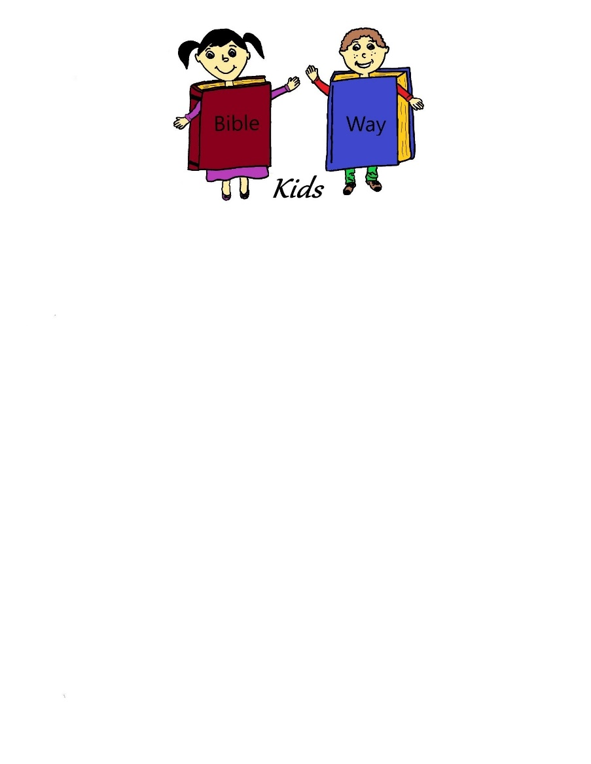

A Bible Way Kids curriculum compiled by:  
Heritage Family Church  
3840 N. Seneca, Wichita, KS 67204  
316-942-6652



**Caution: Construction Ahead**

**Table of Contents**

**Lesson One: The Master Builder: God Created Man and Woman**

**Lesson Two: The Boat Builder: Noah**

**Lesson Three: The Tower Builders: The Tower of Babel**

**Lesson Four: The Altar Builder: Abraham**

**Lesson Five: The Idol Builders: The Golden Calf**

**Lesson Six: The Tabernacle Builders: The Tabernacle in the Wilderness**

**Lesson Seven: The Temple Builder: Solomon**

**Lesson Eight: The Wall Builder: Nehemiah**

**Lesson Nine: The House Builders: The Wise Man and the**

**Foolish Man**

**Lesson Ten: The Church Builder: Peter**

**Lesson Eleven: Party and Review**

**Caution: Construction Ahead**

The Caution: Construction Ahead series is all about building. Building of walls, idols, boats and lots of other things, even the building of people and the church.

The boys will especially enjoy this series but the girls can join in the fun too.

The room décor ideas are endless. Lots of construction signs, tools, caution tape. You can even tape black table cloths on the tables and use colored duct tape to make your road stripes.

The teachers will have hard hats (real or plastic), work aprons or tool belts. The men in denim or khaki and work shirts. The ladies in denim or khaki skirts and work shirts.

Happy Building!



**Caution: Construction Ahead**

**Lesson One: The Master Builder: God Created Man and Woman**

**Lesson at a Glance**

**Welcome:** Tool aprons or belts (can be purchased online or one of the building stores might be willing to donate)

**Pre-session:** White construction paper, art materials

**Offering:** Tool box

**Craft:** Tool aprons or belts from Welcome, art materials, puff paints, markers

**Memory Verse:** Dry erase or chalk board, construction paper, markers

**Extended Game or Activity:** Gingerbread men (can be homemade or store bought), tube frosting, sprinkles, small candies, baggies if children are taking them home

**Caution: Construction Ahead**

**Lesson One: The Master Builder: God Created Man and Woman**

**Scripture Text: Genesis 1:26-31, Genesis 2:7-25**

**Memory Verse: Proverbs 24:3** Through wisdom is an house builded; and by understanding it is established.

**Welcome:** Give the children a warm welcome today and give each one a tool apron to decorate.

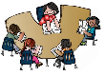**Pre-session:** Give the children white construction paper and various art materials, buttons, etc… and let them create a snowman or snow woman. Suggest to them things that they can add as they work. Talk about God creating man and woman in the Garden of Eden.

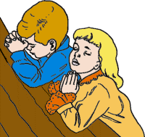**Prayer**: Pray with the children and talk to them about who built (created) them. Thank God today for the way he has made each one.

**Offering**: Let the children put their offering in a tool box during this series. It can be an old tool box from home or a children’s type tool box.

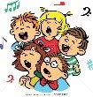**Songs:** Building up the Temple, Isn’t He Wonderful, Deep and Wide

**Craft:** Let each child decorate the tool apron that they were given. They can use puff paints, markers or other art materials. Make sure they put their names on their apron. The children may take these home at the end of the session today.

**Memory Verse:** Write the memory verse on the dry erase or chalk board. Make a drawing of a large tool box on a piece of poster board. Give each child a piece of construction paper and let them make their own tool. Let them glue the tool on another sheet of construction paper and write the memory verse below it. Read the memory verse with the children several times as a group.

**Lesson:** Our new series today is all about creating and building things. Another word for that is construction. We all have fun creating new things and putting our own ideas into some new thing.

That’s what God did when he created man and woman. He was the first master builder. God made a beautiful world just by speaking it into existence. He created everything in the world then. God decided that he wanted to make someone to live in His beautiful world.

The Bible tells us in Genesis that God created man in his own image. He formed man of the dust of the ground and breathed life into his nostrils the breath of life and man became a living soul. God took good care of the first man, he planted a garden-The Garden of Eden and there he put the man whom he had formed. God made everything grow for Adam and gave him good food to eat. He provided for the man he had made.

God did something very special for Adam, he caused a deep sleep to fall upon Adam. While Adam slept he took one of his ribs and closed up the flesh. He took the rib that he had taken from Adam and made a woman. He created again. He brought the woman to Adam. Adam was never lonely. He had a wife to help him take care of the Garden and the animals. I think God is a wonderful master builder. Adam was the first man and Eve was the first woman, but they are not the only ones that God created.

In Jeremiah 1:5 God says before he formed us in our mother’s womb, he knew us. God created every one of us. He loves us and takes care of us just like he did Adam and Eve. He wants good things for his creation.

Let’s pray and thank God for creating us and giving us life.

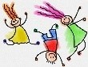**Extended Time Game and Activity:** Bring gingerbread men cookies and let the children decorate them with frosting and sprinkles and candies. The children can eat them now or take them home.



**Caution: Construction Ahead**

**Lesson Two: The Boat Builder: Noah**

**Lesson at a Glance**

**Pre-session:** Homemade or purchased play dough, plastic animals, plastic people

**Offering:** Toolbox

**Craft:** Arks copied on card stock (Resources)-one per child, craft sticks, glue, crayons

**Memory Verse:** Dry erase or chalk board Large Ark out of brown craft paper, art materials

**Lesson:** Hammer, saw, wood, nails

**Caution: Construction Ahead**

**Lesson Two: The Boat Builder**

**Noah**

**Scripture Text: Genesis 5:32-10:1**

**Memory Verse: Psalm 127:1** Except the Lord build the house, they labour in vain that build it …

**Welcome:** Welcome each child with a warm smile.

**Pre-session:** Give the children each a baggie of homemade brown play dough and some plastic animals and people. Let the children build an ark with the play dough and add the animals and people to the boat. Talk to them about who built the ark and why he built it.

**Prayer:** Pray with the children today asking God to touch each one and let them learn about Him today.

**Offering:** Let children place their offering in the tool box.



**Songs:** Who Built the Ark?, Father Abraham, Jesus Loves Me

**Craft:** Give each child a picture of an ark drawn on card stock. Give them craft sticks to glue on as gopher wood. The children can add animals outside the boat ready to get in and color the craft sticks brown if they choose.

**Verse:** Write the memory verse on dry erase or chalk board. Make a large ark to put on the wall out of brown craft paper. Let the children each make and cut out an animal to put in the memory verse ark. The children will hand the animals to the teacher when completed and the teacher can write words or phrases of the memory verse on them. Mix them up and let the children put them in order on the ark. Read the memory verse several times with the children.

**Lesson:** (Have a few tools-hammer, saw, wood to use in the story). By now you know our story is about a man named Noah. Noah was a regular guy just like you and me. He had a wife, three sons, worshipped God, he probably even a dog or a cat. He could have been a carpenter, he seemed to know how to build things. He probably had a lot tools.

When Noah was alive, other people on the earth were evil. (Read Gen. 6:5-7) Sounds like it would be a pretty scary time to live in. Everyone was doing whatever they wanted to or what they thought was good at the time. But Genesis 6:8 says, “But Noah found grace in the eyes of the Lord.” Noah loved God and guess what, God loved Noah. God trusted Noah and though he was upset with mankind, he was not going to destroy Noah. He gave Noah a job instead.

(Read Gen. 6:14-17) How big is that boat? I’m glad you asked!

Short Answer: About 450 feet long, 75 feet wide and 45 feet high, divided into 3 levels [or decks] It was taller than a 3 story building.It had a total deck area the size of 36 lawn tennis courts or 20 basketball courts.It was as long as a football field goalpost to goalpost and about as wide.

[Email](http://beyondflannelgraph.wordpress.com/the-ark/how-big-was-the-ark/?share=email)

* [Print](http://beyondflannelgraph.wordpress.com/the-ark/how-big-was-the-ark/#print)
* [Facebook](http://beyondflannelgraph.wordpress.com/the-ark/how-big-was-the-ark/?share=facebook)
* [Reddit](http://beyondflannelgraph.wordpress.com/the-ark/how-big-was-the-ark/?share=reddit)

Wow! That’s a big job! Noah got to work, and put his sons to work too. Shem (the oldest), Ham (the middle child), and Japheth (the youngest child). There was a lot of work to do, not only did they have to build the boat they also had to collect the animals. Mrs. Noah went to work too. She kept the schedule and made sure there was dinner on the table. By the time the boat was ready to float, she had some daughter-in-laws to help her. Good thing too because God had also told Noah to go out and get animals to put on the boat. Someone had to feed the animals and clean up after them. So, they all worked. (Pull out the tools and saw or bang on some boards.) The whole job took around 120 years. Did you know that Noah was not only a carpenter but a preacher? Yes, he preached to all those that could hear him. He went and bought some tools and told the seller that God was going to send a flood and to turn from his wicked ways. When he went to buy some food, he preached to them too. When the people heard Noah, they made fun of him because they were happy in their sins. In the end, they didn’t get in the boat.

No matter what people thought of Noah, the floods still came. The earth opened up and released water, the skies poured down water, the water came from every direction. God saved Noah and his family and the animals on the ark.

After 40 days and nights God brought the big boat to dry ground. When Noah and his family stepped off the ark one of the first things Noah did was build an altar to God. He worshipped God and thanked him for what he done for him.

Because Noah was faithful to God and loved Him God took care of him and his family. God will always take care of you too. He loves you and He wants you to love Him. Let’s lift up our hands and praise God for his love and care.

**Extended Time Game and Activity:** Noah’s Memory Game

Seat the children in a circle and let the first child say for example “Noah took a monkey into the ark” the next child in the circle repeats what the first child said and adds another animal. Play continues around the circle with each child repeating and adding animals until one child forgets and sits out. Continue the game as time allows or until all children are out.



**Caution: Construction Ahead**

**Lesson Three: The Tower Builders**

**The Tower of Babel**

**Lesson at a Glance**

**Pre-session:** Sets of Jenga blocks or regular blocks

**Offering:** Toolbox

**Craft:** Rollo candies, white frosting, wafer cookies, mini chocolate chips, mini pretzel sticks, (See picture in Resources-Cookie Trucks)

**Extended Game or Activity:** Bubble gum

**Caution: Construction Ahead**

**Lesson Three: The Tower Builders**

**The Tower of Babel**

**Scripture Text: Genesis 11:1-9**

**Memory Verse: Proverbs 16: 18** Pride goeth before destruction, and a haughty spirit before a fall.

**Welcome:** Welcome each child with a smile.

**Pre-session:** Give the children sets of Jenga blocks to build towers. Regular blocks will work but the Jenga blocks are challenging. Talk with them about whether they think they could build a tower to heaven.

**Prayer:** Pray with the children asking God to help them keep a humble spirit and attitude.

**Offering:** Let the children place their offering in the tool box.



**Songs:** I’ve got the Holy Ghost, The B I B L E, Jesus Loves Me

**Craft:** Make construction trucks out of cookies. Maybe 2-3 per child

**Ingredients:** For each truck: 4 Rollo candies unwrapped, white frosting

2 wafer cookies, 2 mini chocolate chips, 6 mini pretzel sticks. Put the trucks together following the picture in Resources.

**Memory Verse:** Write the last part of the memory verse in scrambled form on the dry erase board.

Pride goeth before destruction nda a htguahy ritisp feoreb a lafl. Proverbs 16:18

Does that look another language to you? I can read the first part but the second part looks hard. Let the children read the verse in the scrambled form and then help them to unscramble and say the verse the right way. That makes sense when it’s all written in the same language. Read the memory verse together explaining the verse to the children.

**Lesson:** Our lesson last week was about Noah and how he built a big boat and how he and his family were saved during a big flood. The builders in our story today were not as pleasing to God.

The people all spoke the same language and shared the same backgrounds. They all had Noah as an ancestor. At one point while they were all traveling from the east, they found a flat piece of ground in the land of Shinar and they decided to stay there for a while. Soon, someone had an idea. One said to another, “Let’s make some bricks, get some slime to use for mortar and build a city and a tower. The tower’s top can reach unto heaven, and we can make a name for ourselves unless we all be separated.” That means they wanted to be people who were praised instead of God. The idea caught on…it was very popular. Then they started building. They had those who were good at designing. They had people who were good at makingbricks. They had people who knew how to make slime stick the best way so the bricks wouldn’t fall. The people got to work. God wanted to see what his people were doing and got upset because of their pride. They wanted to be known for what they could do and didn’t give God the praise for giving them the skills that they had. It disturbed him. Have you ever taught someone how to do something and they showed someone else and they took all the credit without saying that you taught them? Well that’s how God feels when He gives you a skill and you don’t give him the credit. We can’t do anything without God. Well, He wasn’t too happy. He said, “The people all share the same language and the same goals and there is nothing stopping them from doing whatever they want to do. I’m going to change their languages so they cannot understand each other.” So, he did. The people all of a sudden couldn’t understand each other. To them it all sounded like a bunch of strange words. Soon everybody started trying to find others that sounded like them and spoke the same language and they moved away from the city they had built. The bible says that the Lord scattered the people across the face of the earth. And God called their city, Babel, which means Confusion.

It was too bad that the people let pride control their actions. We want to always have a humble heart and not have a proud spirit. Let’s pray and ask God to help us be the way he wants us to be. Pray with the children.

**Extended Game or Activity:** Object Lesson: Bubble Gum Pride

Okay, you guys. Who loves bubble gum? I know I do. What’s more fun than blowing a huge bubble and popping it? Except when it gets in your hair. Did you know that my volunteer today is good at blowing bubbles? *(Call your volunteer up and ask him to begin blowing the bubble slowly.)*

I want to share with you a verse from the Book of Proverbs and my friend is going to slowly blow a big bubble. He may have to take a few turns to get the best bubble possible. The bible talks about something called pride. Does anyone know what pride is? There’s the good kind of pride, like when you drew a nice picture or won the spelling bee. Then there’s the bad kind of pride. The bad kind of pride is when you think that you are better than others, even better than God. Nobody can ride a bike as good as you or read faster. The Bible says that being proud will lead to destruction. Let’s say you are like the gum and the air inside your bubble is pride. What happens when you get too much pride?

(Pop the bubble! Of course, meet with the volunteer before you start and let him know you plan to pop the bubble. If not, you may have and upset child!!)



**Caution: Construction Ahead**

**Lesson Four: The Altar Builder**

**Abraham**

**Lesson at a Glance**

**Pre-session:** Tub of rocks, stuffed animal for a sacrifice

**Offering:** Toolbox

**Craft:** Card stock, crayons

**Caution: Construction Ahead**

**Lesson Four: The Altar Builder**

**Abraham**

**Scripture Text: Genesis 22**

**Memory Verse: I Samuel 15:22b** Behold, to obey is better than sacrifice, and to hearken than the fat of rams

**Welcome:** Give each child a warm welcome and a pat on the back

**Pre-session:** Teach the children to build an altar today. Let the children see the tub of rocks that you have collected. Make sure you have enough to build a good sized altar. Explain to them that back in bible times the sacrifices were animal sacrifices and they built altars to offer them on. Let the children place the rocks in a circle and on top of each other explaining to them as the group works together. When done place the stuffed animal you have brought on the altar. Explain to the children that God asks us to be a living sacrifice and live our lives for him. Our altars are a place of prayer every day.

**Prayer:** Pray with the children that they will pray every day in their own way and seek God and be obedient to him.

**Offering:** Let the children put their offering in the tool box.



**Craft:** Write the word OBEY in large letters on a piece of card stock leaving space between the letters. Let the children use different colors of crayons to outline the letters. They will continue outlining the word until the entire page is full.

**Memory Verse:** Write the memory verse on the dry erase board or chalk board. Let the children sit in a circle. The first child will read the first word of the verse, the second child the next word and so forth around the circle, until the verse has been read. Erase a word of the verse and go around the circle again going the other direction. Continue erasing a word and changing directions until the verse has been said completely with all the words erased.

**Lesson:** Remember in pre-session that we talked about altars. In the Old Testament when men worshipped God, they built an altar of earth or of stone, and laid an offering upon it as a gift to God. The offering was generally a sheep, or a goat, or a young ox—some animal that was used for food. Such an offering was called "a sacrifice."

God loved Abraham. There was a time when Abraham’s wife couldn’t have a baby. God gave them a miracle baby when Abraham was 100 and his wife was 90 years old. It was a miracle! Then God wished to see how faithful and obedient Abraham would be to his commands; how fully Abraham would trust in God, or how great Abraham's faith in God would be. God was going to test Abraham.

So God gave Abraham a command He said: "Take now your son, your only son Isaac, whom you love so greatly, and go to the land of Moriah, and there on a mountain that I will show you, offer him for a burnt-offering to me."

This command filled Abraham's heart with pain, yet he would not be as surprised to receive it as a father would in our day; for such offerings were very common among all those people in the land where Abraham lived. Abraham never for one moment doubted or disobeyed God's word. He knew that Isaac was the child whom God had promised, and that God had promised, too, that Isaac should have children, and that those coming from Isaac should be a great nation. He did not see how God could keep his promise with regard to Isaac, if Isaac should be killed as an offering; unless indeed God should raise him up from the dead afterward.

But Abraham undertook at once to obey. God's command. He took two young men with him and a donkey laden with wood for the fire; and he went toward the mountain in the north, Isaac, his son, walking by his side. For two days they walked, sleeping under the trees at night in the open country. And on the third day Abraham saw the mountain far away. And as they drew near to the mountain Abraham said to the young men:

"Stay here while I go up yonder mountain with Isaac to worship; and when we have worshipped, we will come back to you." Abraham believed that in some way God would bring back Isaac to life. He took the wood from the donkey and placed it on Isaac, and they two walked up the mountain together. As they were walking, Isaac said:

"Father, here is the wood, but where is the lamb for the offering?"

And Abraham said, "My son, God will provide himself a Lamb for a burnt offering."

And they came to the place on the top of the mountain. There Abraham built an altar of stones and earth heaped up; and on it he placed the wood. Then he tied the hands and the feet of Isaac, and laid him on the altar, on the wood. And Abraham lifted up his hand, holding a knife to kill his son. Another moment longer and Isaac would be slain by his own father's hand.

But just at that moment the angel of the Lord out of heaven called to Abraham, and said:

"Abraham! Abraham!"

And Abraham answered, "Here I am, Lord." Then the angel of the Lord said:

"Do not lay your hand upon your son. Do no harm to him. Now I know that you love God more than you love your only son, and that you are obedient to God, since you are ready to give up your son, your only son, to God."

What a relief and a joy these words from heaven brought to the heart of Abraham! How glad he was to know that it was not God's will for him to kill his son! Then Abraham looked around, and there in the thicket was a ram caught by his horns. And Abraham took the ram and offered him up for a burnt-offering in place of his son. So Abraham's words came true when he said that God would provide for himself a lamb.

The place where this altar was built Abraham named Jehovah-jireh, words in the language that Abraham spoke meaning, "The Lord will provide."

**Extended Game or Activity:** Play a game of Simon Says with the children.



Caution: Construction Ahead

Lesson Five: The Idol Builders

The Golden Calf

Lesson at a Glance

**Pre-session:** Small statue, game system controller, book

**Offering:** Toolbox

**Craft:** Hand cut out (Resources)-one per child, 8.5x5.5 fun foam sheets-one per child, scissors, sharpies, jumbo craft sticks, strapping tape

**Memory Verse:** Three to four sets of 8-9 spring clothespins with the memory verse written in words or phrases 3-4 wire clothes hangers

**Lesson:** Costume jewelry earrings, golden calf(can spray paint a regular cow or however you choose to make one, a carving tool, small kettle, poster board fire, unsweetened lemonade in the kettle, pitcher of water, small cups

**Extended Game or Activity:** On a poster board draw a golden calf and cut it into as many pieces as you have children, cut it apart and put a piece of Velcro on the back of each piece. On another poster board write, “God is #1. Put the other sides of the Velcro on the #1 poster board and place the golden calf on top.

(You will have the golden calf with Velcro on top of the #1 poster)

**Caution: Construction Ahead**

**Lesson Five: The Idol Builders**

**The Golden Calf**

**Scripture Text: Exodus 32**

**Memory Verse: Exodus 20:3, 4a** Thou shalt not have no other gods before me. Thou shalt not make unto thee any graven image,

**Welcome:** Welcome each child with a warm smile.

**Pre-session:** Object lesson: Idolatry-Materials needed: Small statue, Game System controller, book

(Show the statue.) How many of you can tell me what this is? That’s right, it is a statue. Now how many of you have statues in your home that you bow down to every day and pray to? None of you? Are you sure you don’t worship something other than God? Sometimes we do and we don’t even realize that that we are doing it. We don’t mean to do that, but we do. (Show the controller.) Can someone tell me what this is? How many of you play video games? How many of you have ever gotten a high score on a video game? It takes a lot of hard work and a lot of time to get high scores. Did you know that this could be an idol? This could be something that you go home and worship every day. That’s right. If you play your game instead of reading God’s Word, then you are putting the game before God. If you play your game instead of spending time in prayer, then you are putting the game before God. If you play your game so much that when it’s time to go to bed, you fall asleep while you are praying, then you are putting the game before God. Your video game has become an idol. This is just a simple book in my hand, but it can become an idol too. I can spend so much time reading that I’m too tired to pray or read my Bible. I figure I can just do it tomorrow, but the next day I just pick up my book and get too busy again. Many times people do not realize that the time they spend with other activities like sports, games, etc… can become an idol that they worship if it takes away the time they should be spending with God. You must always put God first. He must have priority, or first place, in your daily activities. If He doesn’t, then you may just have an idol in your house.

**Prayer:** Ask God to help all of us to put Him first in our lives.

**Offering:** Let the children place their offering in the tool box.

**Songs:** I’ve Got Jesus on my Mind, What a Mighty God We Serve, Trust and Obey.

**Craft: Items Needed:**

* fun foam sheets (8.5" x 5.5")
* scissors
* a Sharpie
* jumbo craft sticks (6" long)
* hand template
* scissors for each student
* shipping tape (or any tape to secure the stick)

**Instructions:**

1. Use a Sharpie to trace the OUTER lines of the hand template onto the fun foam sheet.

2. Remove the template and let the children look at the template and draw the interior lines of the hand.

3. (Help the children with this step)At the bottom center of the foam hand (where the craft stick will go) use scissors to slice two 3/4" horizontal cuts parallel to each other at about 3/8" and 5/8" above the bottom edge of the hand.

4. Write on the lower palm area of the hand in large, dark letters: GOD IS #1

5 .Print this memory verse onto the craft stick, leaving about 2" of one end of the stick blank: *You shall have no other gods before me. Exodus 20:3*

**Memory Verse:** Write the memory verse on the dry erase board. Give groups of two or three children sets of six or seven clothespins with the memory verse written in phrases or words on them. Give each group a clothes hanger. Let the children work together to put their verse in order and then to pin the clothes pins in order on the hanger. The first group to complete it is the winner. Let each group read their memory verse out loud and then read it as a group.

**Lesson:**  (Gather the materials for the story and seat the children in a semi-circle around you.)

Remember Moses was in some of our previous stories? He was the one who led the children of Israel out of Egypt and through the Red Sea. Now the children are in the wilderness and Moses has gone up to a mountain to receive instructions from God.

His brother Aaron has been approached by some of the Israelites with a request.

They told Aaron that since Moses has been gone quite a while maybe something had happened to him and he might not come back. They wanted Aaron to help them make an idol to worship like they had back in Egypt when they were in bondage. That seems silly to us. Now they have their freedom and they want to worship the way their captors worshipped. That sounds silly, but that’s what they wanted to do.

Aaron finally gave in to them and told them to gather up their gold earrings and bring them to him. (Show the children the earrings.) Aaron took a tool and made the earrings into a golden calf. (Show the golden calf) The people were very happy and began to worship the calf. Aaron even built an altar and said that tomorrow they would have a feast. The Bible says, “and they rose up early on the morrow, and offered burnt offerings, and brought peace offerings; and the people sat down to eat and drink and rose up to play. They were having a great time worshiping the golden calf. Can you imagine, after all the great things God had done for them? They were placing the golden calf ahead of God in their worship. Guess what? God wasn’t happy about it.

The Lord told Moses to go back down the mountain to the people. He told Moses he was so angry that He was going consume the people. That means God was going to kill them. Oh my! Moses sought the Lord and asked Him to change his mind. After Moses had talked with God and begged Him to spare the people the Bible says that God repented of that which he thought to do unto his people. It’s a good thing they had a man who stood between them and God. Our Pastor does that sometimes. He stands and asks God to give people another chance to live for Him. Thank God we have a Pastor that will do that for us.

Moses went down from the mountain with the instructions in stone that God had given him. When he saw what was going on Moses was very angry, he cast the tables out of his hands, and brake them. He took the calf which they had made and burnt it in the fire. (Put the golden calf in the kettle with fire that has been made), then he ground the calf into powder and put it in water and made the children of Israel drink of it. (the kettle will have unsweetened lemonade in it and when the water is added will make the drink that you can serve the children, most of them will not like the sour drink). It probably tasted as yucky as what you just drank.

There were those that were still not on the Lord’s side and Moses commanded them to be killed. That day 3000 men were killed.

That was a terrible sin that the children of Israel committed wasn’t it. But, remember our lesson in pre-session. We can be just as guilty if we put things before our devotion to God. They can become Gods to us.

Let’s sit quietly with our eyes closed and think about the way we live. Are there things in our lives that we love more than God or that we place above our time with God? Don’t tell anyone else right now, let’s talk to God and tell him and ask him to forgive us if we do. Let’s all pray together and seek God. Pray with the children.

**Extended Time Game and Activity:** Using the poster board with the Velcroed golden calf that has been made, let the children take turns answering review questions about the story. If the child answers the question correctly they get to remove a piece of the golden calf. Play continues until the calf is totally removed and underneath God is #1 is showing. Make sure all the children have a chance to play.



**Caution: Construction Ahead**

**Lesson Six: The Tabernacle Builders**

**The Tabernacle in the Wilderness**

**Lesson at a Glance**

**Pre-session:** White paper, pencils, crayons, tabernacle picture (Resources)

**Craft:** Graham crackers, icing, plastic knives, additional candies

**Memory Verse:** Leftover gift wrap, index cards, marker, tape-Write the memory verse on index cards one phrase per card( 5-6) cards. Make a fist sized ball with gift wrap. Tape together. Tape one index card to the ball, wrap the ball in another piece of gift wrap, tape another index card to the ball, wrap in another piece of gift wrap. Continue until all the index cards have been wrapped. Follow play instructions in lesson. Make 2-3 balls depending of the number of children you have.   
They will be divided into 2-3 teams.

**Caution: Construction Ahead**

**Lesson Six: The Tabernacle Builders**

**The Tabernacle in the Wilderness**

**Scripture Text: Exodus 26**

**Memory Verse: I Corinthians 6:19** What, know ye not that your body is the temple of the Holy Ghost which is in you, which ye have of God, and ye are not your own?

**Welcome:** Greet each child with a warm welcome.

**Pre-session:** Give the children a white piece of paper and a pencil or crayons and let them draw a picture of their church. After they are done give them a picture of the tabernacle to color. Talk them about the Old Testament tabernacle and our church today. Point out the obvious differences. (You need not go into the detail of the tabernacle plans-our main objective today is to teach the children the importance of the church)

**Prayer:** Pray with the children thanking God for their church today.

**Offering:** Let the children put their offering in a church bank today.

**Songs:** I’m in This Church, Oh, How I Love Jesus, It’s Bubbling

**Craft:** Give the children graham crackers and frosting and let them build a church. It can be a replica of their church or a church they would like to build. They are the master builders today. Hand out extras to go on the churches that you feel the children would like to add-any candies they could use for windows, steeples, etc…

**Memory Verse:** Divide the children into three groups and give each group the memory verse ball. At go, the first child will unwrap the first level of the ball and take out the slip with the part of the verse on it. They will pass the ball to the next child in line and it will continue down the line until all the slips have been unwrapped. The children will then work to put the memory verse together in order and read it out loud as a group. The first group finished are the winners. Read the verse together as a group.

**Lesson:** Our story today is again about the Children of Israel, the Hebrews. Maybe because they built a lot of things, we are learning so much about them. After the experience with the golden calf, Moses called all of the people together and told them God had special things that He wanted them to do. Moses started by telling them, like he had before, that God wanted them to remember the Sabbath Day. They still needed to remember this day and to keep it holy.

Because the children of Israel had seen the people in Canaan and Egypt bow down to idols for many years, they did not think it was strange to worship idols. The people at that time seemed to want to worship something that they could see with their eyes. The children of Israel could not see God because God was everywhere.  Moses began to explain what God had in His mind for the people to do: They were going to make a place where God could live among His people. It was called the tabernacle and it was a very special place. It was unusual because it wasn't like one of the houses that we know. The people lived in tents and were traveling. Where were they going? That's right! To the Promised Land! So, like the tents that the people lived in which could be put up and taken down, that is how God's house was. It was like a big tent that was put on poles for easy traveling on the priests' shoulders, moving when God told the people to move.

Moses told the people that God commanded anyone with a willing heart to bring offerings of gold, silver and brass for the tabernacle. They were to bring oil for light, and spices, and onyx stones. God commanded that any of the people who were skillful or had a special talent to make things to come and create all the things that God wanted them to make. God told them exactly what to do and where things should go.

There were many people who gave willingly and freely. There were women who spun fabric and goat's hair with their hands. Even the leaders of the people gave precious onyx stones. Every man and woman brought something to offer (Ex. 35:29).

Moses said that God called certain men and filled them with special knowledge, wisdom, and understanding to work with the gold, silver, and brass, and how to cut stones the right way, and carving wood, and other artistic works, and how to embroider and weave. The people kept bringing so many offerings that finally Moses had to tell the people to stop because they had enough materials.

God told the people exactly how he wanted things to be made and where to place every item. They could not go to the store and buy things since they were out in the wilderness, so God commanded them to make everything for the tabernacle and told them how to do it. God told them how to make special pieces of furniture for the Tabernacle and the special clothing he wanted the priests who went into the tabernacle to wear. God had a plan for his church in the wilderness and He wanted everything to be done right. There was even a Holy of Holies, the place where His presence dwelt.

Finally the tabernacle was finished and the glory of the Lord filled the tabernacle.

When the Children of Israel moved from place to place there were even specific directions on how to move the tabernacle.

I think God still has special directions about our bodies which are the temple of the Holy Ghost and about how we treat the things in the church that we attend.

If we have the Holy Ghost we want to be sure not to get our temple dirty and to keep it clean. We want to please God with Holy things in our lives.

In our physical temples that we worship in we want to make sure they are clean too, we don’t want to drop trash and not pick it up. We don’t want to run or play in the sanctuary of the church, it’s a Holy place.

Let’s all thank God for the church today and thank him for the Holy Ghost that we have that makes us a temple for Him. Pray with the children today.

**Extended Time Game or Activity:** Play a game of Follow the Leader



**Caution: Construction Ahead**

**Lesson Seven: The Temple Builder**

**Solomon**

**Lesson at a Glance**

**Pre-session:** Dry spaghetti noodles, marshmallows, small candies, toothpicks, spice drops, building blocks.

**Craft:** Make several road and construction signs-changing them to be church related-Example: God at Work, Walk with Jesus, One Way to God, construction paper, art materials, contact paper

**Memory Verse:** Solo cups with phrases of the memory verse written on the edge of the cups. Make a set for each child in the group

**Extended Time Game or Activity:** Chalk or Duct tape, two cones, paper plates with middle cut out (large enough to fit over the cones), review questions.

**Caution: Construction Ahead**

**Lesson Seven: The Temple Builder**

**Solomon**

**Scripture Text: I Kings 6, II Chronicles 3**

**Memory Verse: Isaiah 66:1** The heaven is my throne and earth is my footstool: where is the house that ye build unto me? And where is the place of my rest?

**Welcome:** Welcome each child with a smile and a warm greeting.

**Pre-session:** Set-up several building stations for the children to build the temple today. One: dry spaghetti noodles, marshmallows, small candies. Two: toothpicks, spice drops, small candies. Three: building blocks. Let the children rotate to the different stations, taking their food buildings with them. Refill the stations as needed.

**Prayer:** Pray with the children today encouraging them to be thankful for the beautiful church that they attend.

**Offering:** Let the children place their offering in the church bank.

**Craft:** Show the children the signs that you have made and give them materials to make their own. Let them create their own sayings on their signs and then laminate two or three to take home. They also could be added to the room décor until the last lesson.

**Memory Verse:** Write the memory verse on the dry erase or chalk board. Give the children each a set of the solo cups that have been made with the memory verse on them. Let the children work to place the cups in order stacking them to create the memory verse. Let each child read the memory verse to the group and then everyone read it together. The child can take the cups home at the end of the session today.

**Lesson:** Remember last week we talked about the tabernacle that was built in the wilderness? Today we’re going to talk about the temple that God allowed Solomon David’s son to build.

BEFORE David died, he gave Solomon the plans from God for building Jehovah’s temple. In the fourth year of his rule, Solomon began building the temple, and it took seven and a half years to finish it. Tens of thousands of men worked on the temple, and the building cost lots and lots of money. This is because so much gold and silver were used in it. It was a majestic place to worship a majestic God.

The temple had two main rooms, just as the tabernacle had. But these rooms were twice the size of those in the tabernacle. Solomon had the Ark of the Covenant put in the inside room of the temple, and the other things that were kept in the tabernacle were put in the other room.

When the temple was finished, there was a big celebration. Solomon knelt in front of the temple and prayed. “Not even all of heaven is large enough to hold you, Solomon said to Jehovah, how much less, then, can this temple hold you. But, O my God, please listen to your people when they pray toward this place.”

When Solomon finished his prayer, fire came down from heaven. It burned up the animal sacrifices that had been made, a bright light from God filled the temple. This showed that God was listening, and that he was pleased with the temple and Solomon’s prayer. The temple, rather than the tabernacle, now became the place where the people come to worship.

I’m sure the people were very thankful for the temple and a beautiful place to worship. All of you should be thankful for your church too. Without the church we wouldn’t have a place to learn about God and learn the plan of salvation. We have a wonderful place to worship God. Every church is beautiful because God says that when two or three gather together in his name He is there. If God is in our church, we know it’s a beautiful place. Let’s all lift our hands and thank God for his presence and the church He has given us. Pray with the children.

**Extended Game or Activity:** With chalk or tape mark off a line for the children to stand behind. Have two teams and two cones set up about three to four feet away from the line. Give each group a set of paper plates with the middle cut out of them (large enough to fit over the cone).

The first group will be given a review question about the story. If they can answer the question they will have a chance to throw the paper plate over the ring. If they can’t answer the question, the other team gets a chance to answer and gets the next question first. Play continues until all the children have a chance to answer a question. The team with the most rings on the cones wins the game. (You could have two winners possibly-one with the most correct answers and one with the most rings).



**Caution: Construction Ahead**

**Lesson Eight: The Wall Builder**

**Nehemiah**

**Lesson at a Glance**

**Welcome:** Small baggie of Legos for each child

**Pre-session:** Legos

**Craft:** Slips of paper with jobs on them for building a brick paper wall on the classroom wall (see lesson) Materials for the different areas

**Memory Verse:** Dry Erase of Chalk Board-Duplo blocks (large Legos) write the memory verse one word or phrase on each Duplo block, make two sets.

**Extended Time Game or Activity:** Dry Erase or Chalk Board

**Caution: Construction Ahead**

**Lesson Eight: The Wall Builder**

**Nehemiah**

**Scripture Text: Nehemiah 3, 4**

**Memory Verse: Nehemiah 4:6** So built we the wall; and the wall was joined together unto the half thereof: for the people had a mind to work.

**Welcome:** Give the kids a warm welcome and a small bag of Legos.

**Pre-session**: Let the children use the Legos that have been given them to build a wall. Each child can make a section of the wall with their Legos. When all the wall sections are built, the children can add all the sections together to make a big wall. The people working with Nehemiah had a mind to work.

**Prayer:** Thank the Lord today for unity and having a mind to work together. Explain to the children the importance of working together when we work for his kingdom.

**Offering:** Let the children place their offering in the tool box.

**Songs:** Father Abraham, Every Promise in the Book is Mine, Praise Him, Praise Him

**Craft:** Set up an assembly line to build a large paper brick wall on the classroom wall. Hopefully all will go well and the children will learn the value of each person having a job and doing it. Have slips of paper with jobs for building the wall listed. Let the children pick a slip of paper and go to that area to do their job. (Have areas in the room designated for the work, example: one area for drawing the bricks, one area for coloring the bricks, one area for cutting out the bricks, etc..

Set a timer for the building of the wall and see how well the children work together in unity to build the wall. It will be interesting to observe and to see how tall the wall will get built.

**Memory Verse:** Write the memory verse on the dry erase or chalk board. Using 8-10 Duplo blocks (large Lego type blocks), write one to two words of the memory verse on each block (make two sets). Choose two teams. At the word go the children work to put the memory verse together by connecting the blocks. The first group to connect the blocks and say the verse together wins. Be sure to check that they have the blocks in the correct order. This game can be tricky.

**Lesson:** Many years after Solomon built the temple, a faithful Jew in Shushan named Nehemiah became concerned about his fellow Jews in Jerusalem. Nehemiah held the important job of cupbearer to King Artaxerxes of Persia. The King trusted Nehemiah as a friend, when he learned Nehemiah was worried about his people, he wanted to help. Nehemiah had not even been born when the first captives (they were captured by the Babylonians) went back to Jerusalem with Zerrubabel about a hundred years before. He must have heard many exciting stories about the new temple and God’s promise to bless them all again. Imagine Nehemiah’s distress, then, when someone from Judah brought bad news to the palace one day.  
  
“The survivors who are left… are in great distress and reproach.” reported his brother and the men with him. “The wall of Jerusalem is also broken down, and its gates are burned with fire.”  
  
Nehemiah was so upset he sat down and wept. For several days he mourned and fasted before the Lord, praying for His mercy and for favor with the king so he could get help for his people. God’s answer came later as King Artaxerxes asked Nehemiah why he was so sad. When Nehemiah told him about Jerusalem, the king gladly sent letters providing for his safety and for wood to build the temple and the wall, along with some of his soldiers.  
  
Once he was in Jerusalem, Nehemiah saw his job would not be easy. A secret night tour around the city showed his brother had told the truth. Not only was the wall and its gates in awful shape - - huge piles of rubbish would have to be removed before everything could be repaired.  
  
But Nehemiah was not afraid of hard work. He told the leaders how the Lord had given him favor with the king. “Come, and let us rebuild the wall of Jerusalem. “Nehemiah urged, “that we may no longer be a reproach.” How happy Nehemiah was when they replied, “Let us rise up and build!” So the good work was begun.

When their enemies heard the Jews were rebuilding the wall they tried to stop them. But Nehemiah replied the Lord was helping them.  
  
However, a Samaritan named Sanballat continued to harass them, mocking, “What are these feeble Jews doing?… Will they complete it in one day? Will they revive the stones from the heaps of rubbish, stones that are burned?” An Ammonite named Tobiah joined him, sneering, “Whatever they build - - if even a fox goes up on it, he will break down their stone wall!”  
  
Nehemiah would not stop the work to answer the enemies. Instead, he prayed to God, saying, “Hear us, O our God, for we are despised. Turn their reproach on their heads!” And his people went on working until all the gaps were filled in up to half the wall’s height.  
  
Now Sanballat and his cronies began making plans to fight the Jews. Some were afraid, but Nehemiah told them, “Do not be afraid of them. Remember the Lord, great and awesome, and fight for your brethren, your sons, your daughters, your wives and your houses.”  
  
From that day on half the people did the work while the other half stood guard with swords, spears and bows. Those who carried materials had weapons in one hand and supplies in the other, and each of the builders wore a sword at his side. Nehemiah also ordered the men to stay inside Jerusalem at night to guard the wall. Each one slept with his clothes on, taking them off only to be washed.  
  
When Sanballat and the other men saw the wall going higher, they tried to trick Nehemiah into leaving the work so they could harm him. But he would not listen. Instead he asked the Lord for help, praying, “My God, remember Tobiah and Sanballat, according to their works…”  
  
Finally, after just working fifty-two days, the wall was finished. How happy they were! When the nations around them saw it, they realized the work had been done by the God of Judah - - and that they were helpless before Him.

What an amazing story! One man’s desire to do a work for God and the people’s desire to work with him brought about a great thing. God worked with Nehemiah and the people.

That’s the beauty of unity. In the church we want to work together in unity. We are all working for the same goal: to go to heaven and take as many people as we can with us. We want to tell everyone about Acts 2:38, the plan of salvation.

Let’s pray right now and ask God to help us to always work together. We don’t want to fight each other, we only want to fight the devil. Pray with the children.

**Extended Time Game or Activity:** Play a game of Hangman with the children using words in the story.



**Caution: Construction Ahead**

**Lesson Nine: The House Builders**

**The Wise Man and the Foolish Man**

**Lesson at a Glance**

**Pre-session:** Plastic table cloths, white glue in bottles, cardboard or card stock, play sand, cups, trash can

**Offering:** Large rock

**Craft:** Nice sized rocks, art materials

**Memory Verse:** Dry erase or Chalk board, construction paper, crayons

**Extended Time Game and Activity:** Word search (Resources)

**Caution: Construction Ahead**

**Lesson Nine: The House Builders**

**The Wise Man and the Foolish Man**

**Scripture Text: Matthew 7:24-27**

**Memory Verse: I Corinthians 3:11** For other foundation can no man lay than that is laid, which is Jesus Christ.

**Welcome:** Welcome each child with a warm smile today.

**Pre-session: (**Before class cover the work area with plastic table cloths-if possible work outside to avoid clean-up) Let children use Elmer’s glue to write the word SAND on a piece of card stock or cardboard. (Glue sticks won’t work for this project-must be white Elmer’s type glue). Give each child a small cup of sand to sprinkle over the glue. They will hold their paper over a trash can and shake off the excess sand. Let dry and take home at end of session.

**Prayer:** Pray with the children that we can build our lives on the solid rock of God’s word.

**Offering:** Bring in a large rock for the children to place their offering near.

**Songs:** I’m in This Church, When the Saints Go Marching In, Deep and Wide

**Craft:** Give each child a rock and let them use markers or paints to create rock people or animals. Place art materials on the table for hair, eyes, etc…

**Memory Verse:** Write the memory verse on the dry erase or chalk board. Give the children sheets of construction paper. Have them draw a rock on their paper and write JESUS on the rock. They should then draw a picture of a house on the rock. They can add sun, clouds, grass, etc… At the bottom of the drawing they should write the memory verse. Read the verse and explain the meaning to the children. We want them to understand the meaning of the word foundation.

**Lesson:** Can anyone tell me what the word foundation means? (Let the children give their answers). If I tell you I am going to build a new house, the first thing I want to know is what type of foundation I am going to build it on. The foundation is the most important thing when we are building a house.

I’m going to teach you a song about two men who built houses in the Bible. In fact our story today is about these two men. See if you can sing the words with me the first time through. The second time we sing it we will add actions to the words. (Put the words of the song either on the wall or hold them up where all the children can see them). You guys did great, some of you already knew that song and the actions.

Our story is a parable that Jesus told. A parable is a story that has a real life meaning. Let’s think about this parable. Jesus said one man built his house on a rock. When the winds and the rains came his house stood firm because the foundation was firm like this rock I have in my hand (show the rock). The other man built his house on sand. Perhaps he was too lazy to build on a more solid foundation or he just didn’t know better. When the winds and the rains came something terrible happened to his house. It fell down. It was built on this (show the sand). See how the sand shifts around and moves and it was washed away in the rain. That man probably wished he had built his house on a firmer foundation.

Are you seeing that the foundation is the important thing in building a house? Jesus said that the man who hears His words and doeth them is like the man who built his house on the rock. The man that hears His words and doeth them not is like the man who built his house on the sand.

We want to make sure we hear the word of God and do what it says. The word of God says to repent, be baptized in Jesus name and be filled with the Holy Ghost. That is a wonderful rock to build our lives on. Let’s pray and ask God to help us to build our life on the word of God. Pray with the children.

**Extended Time Game or Activity:** Let the children do a word search today.



**Caution: Construction Ahead**

**Lesson Ten: The Church Builder**

**Peter**

**Lesson at a Glance**

**Welcome:** Church card or church invitation

**Pre-session:** Blank business cards or bland ½ sheets of white paper, art materials

**Craft:** Sugar cookies, icing, disposable knives, pop rocks

**Memory Verse:** Rock

**Extended Time Game or Activity**: Small bag of different types of candy

**Caution: Construction Ahead**

**Lesson Ten: the Church Builder**

**Peter**

**Scripture Text: Matthew 16:13-20**

**Memory Verse: Acts 2:38** Then Peter said unto them, Repent and be baptized every one of you in the name of Jesus Christ for the remission of sins and ye shall receive the gift of the Holy Ghost.

**Welcome:** Welcome each child and give them a church card or church invitation today.

**Pre-session:** Give each child a few blank business cards or blank half sheets of white paper and art materials. Let them create their own church cards or invitations. They can look at the church card or invitation that they have been given if they need address and phone information. Talk to them about inviting people to church and how we want them to know the truth that is preached at our church.

**Prayer:** Let’s worship and thank God today that we have a church with truth to come to today.

**Offering:** Let the children place their offering on or near a bible opened to Acts 2:38.



**Songs:** I’ve got the Holy Ghost; Thank God I am Free, Bless that Wonderful Name of Jesus

**Craft:** Let the children decorate sugar cookies with pop rocks. Give each child a few sugar cookies (homemade or store bought), white frosting, plastic knife and a small bag of pop rocks. Let the children use the plastic knife to frost the cookies and then sprinkle the pop rocks on the cookies. When they eat the cookies they will enjoy the surprise taste.

**Memory Verse:** Seat the children in a circle. Give a rock to the first child, they will say the first word of the memory verse, pass the rock, the next child says the next verse and passes the rock. Passing will continue until the complete verse is said. You can also play musical verse by passing the rock and stopping when the music stops. This is a familiar verse to most of the children, but again we want to plant the plan of salvation in their hearts.

**Lesson:** We have doing some activities about construction lately and today we are going to find out what a rock that we can build our lives on. Not even Satan will be able to prevail against this rock. That’s a pretty strong rock.

Jesus didn't wear anything special to show who he was; so just looking at Jesus, he might have seemed to be like anyone else of his day. As you might imagine, there was a lot of confusion about who Jesus really was. One day, Jesus was with his disciples, Jesus turned to his disciples and said, "Who do men say that I am?"

The disciples had many answers for him. One of the disciples answered, "Some say you are John the Baptist."

"Some say you are Elijah or one of the prophets," answered another.

Jesus questioned the disciples further, he really wanted to know if they knew who he was, “But who do you say that I am?"

"You are the Christ," answered Peter, "the Son of the living God."

The Bible doesn't tell us, but I think that the other disciples might have cheered, "Yea Peter! Good answer! Good answer!"

Jesus looked at Peter and said, "Blessed are you Simon, son of John, because my Father in heaven has revealed this to you. From now on, I will call you Peter (which means rock) and upon this rock I will build my church."

Did you know that there are still many people today who don't know who Jesus is? If you ask, they might say, "He was a great teacher." Or some might say, "He was a great religious leader." They don't know what Peter knew. They don't know what you and I know. They don't know that Jesus was God in flesh. He was altogether God and man.

Jesus wasn’t saying he was going to build his church upon Peter, he was saying he was going to build his church upon the revelation that Peter had, who Jesus really was.

I’m so glad that I know who He is. Let’s sing that song, “I’m glad I know who Jesus is”. That was a great job. All power in heaven and earth is given unto that name. The Bible says we should do everything in that name. We pray in Jesus name, we call on Jesus name in times of trouble, we baptize in Jesus name.

I want you to close your eyes and raise your hands and all of us say Jesus we love your name. Continue a time of worship with the children, praising that wonderful name.

**Extended Time Game and Activity:** Have a small bag of different types of candy in a brown paper bag. (at least one for the number of children you have). Peter knew who Jesus was, let’s see if you can guess what candy I am describing when I look in my bag. Go around the circle or table and describe the kind of candy that you have drawn out, do not let the children see it. If the child can tell what kind of candy it is, they get the candy. Continue the play around the circle. At the end make sure each child gets a piece of candy.

**Caution: Construction Ahead**

**Party and Review**

*This can be a very fun and creative party time and review for the children. Play some of the games that have been played.

*If possible give each child a plastic play construction helmet, these can be found at party stores or at Oriental Trading. Let them take home the road signs that they have made that are on the walls.

*Review the memory verses and see how many they remembered.

*Have small sandwiches (sliders work well), chips, cookies or cupcakes with juice. You can decorate the food items and have fun doing so. The kids can even decorate their own if you choose.

*If possible go outside and set up an obstacle course for the kids using cones and hula hoops and other items to create a course.

*Play a few team games outside. The children could have small cones set up at one end and race each other to grab a cone and take it back to the team. The next person could race down and put the cone back.

The game ideas are endless, the important thing is to have some fun with the kids. That’s what Sunday School is all about, having fun and learning the Word of God.

*Give the children a small introduction of what the next series is going to be. Let them know that next week will be a Holy Ghost Sunday with special things going on. (We do puppets and skits to introduce the next series, and a special lesson. This allows the teachers an extra week to change the décor and get ready for the next series.)



RESOURCES

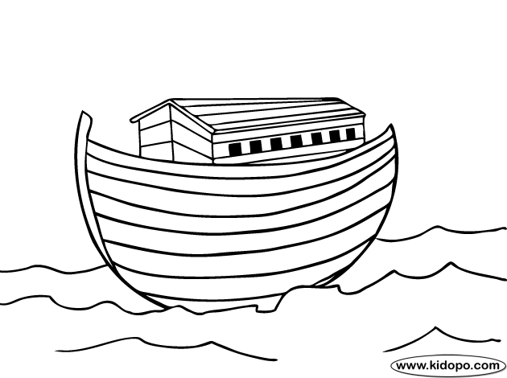

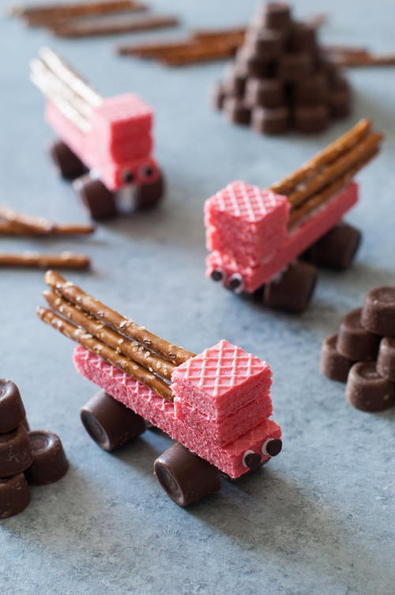

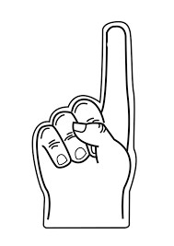

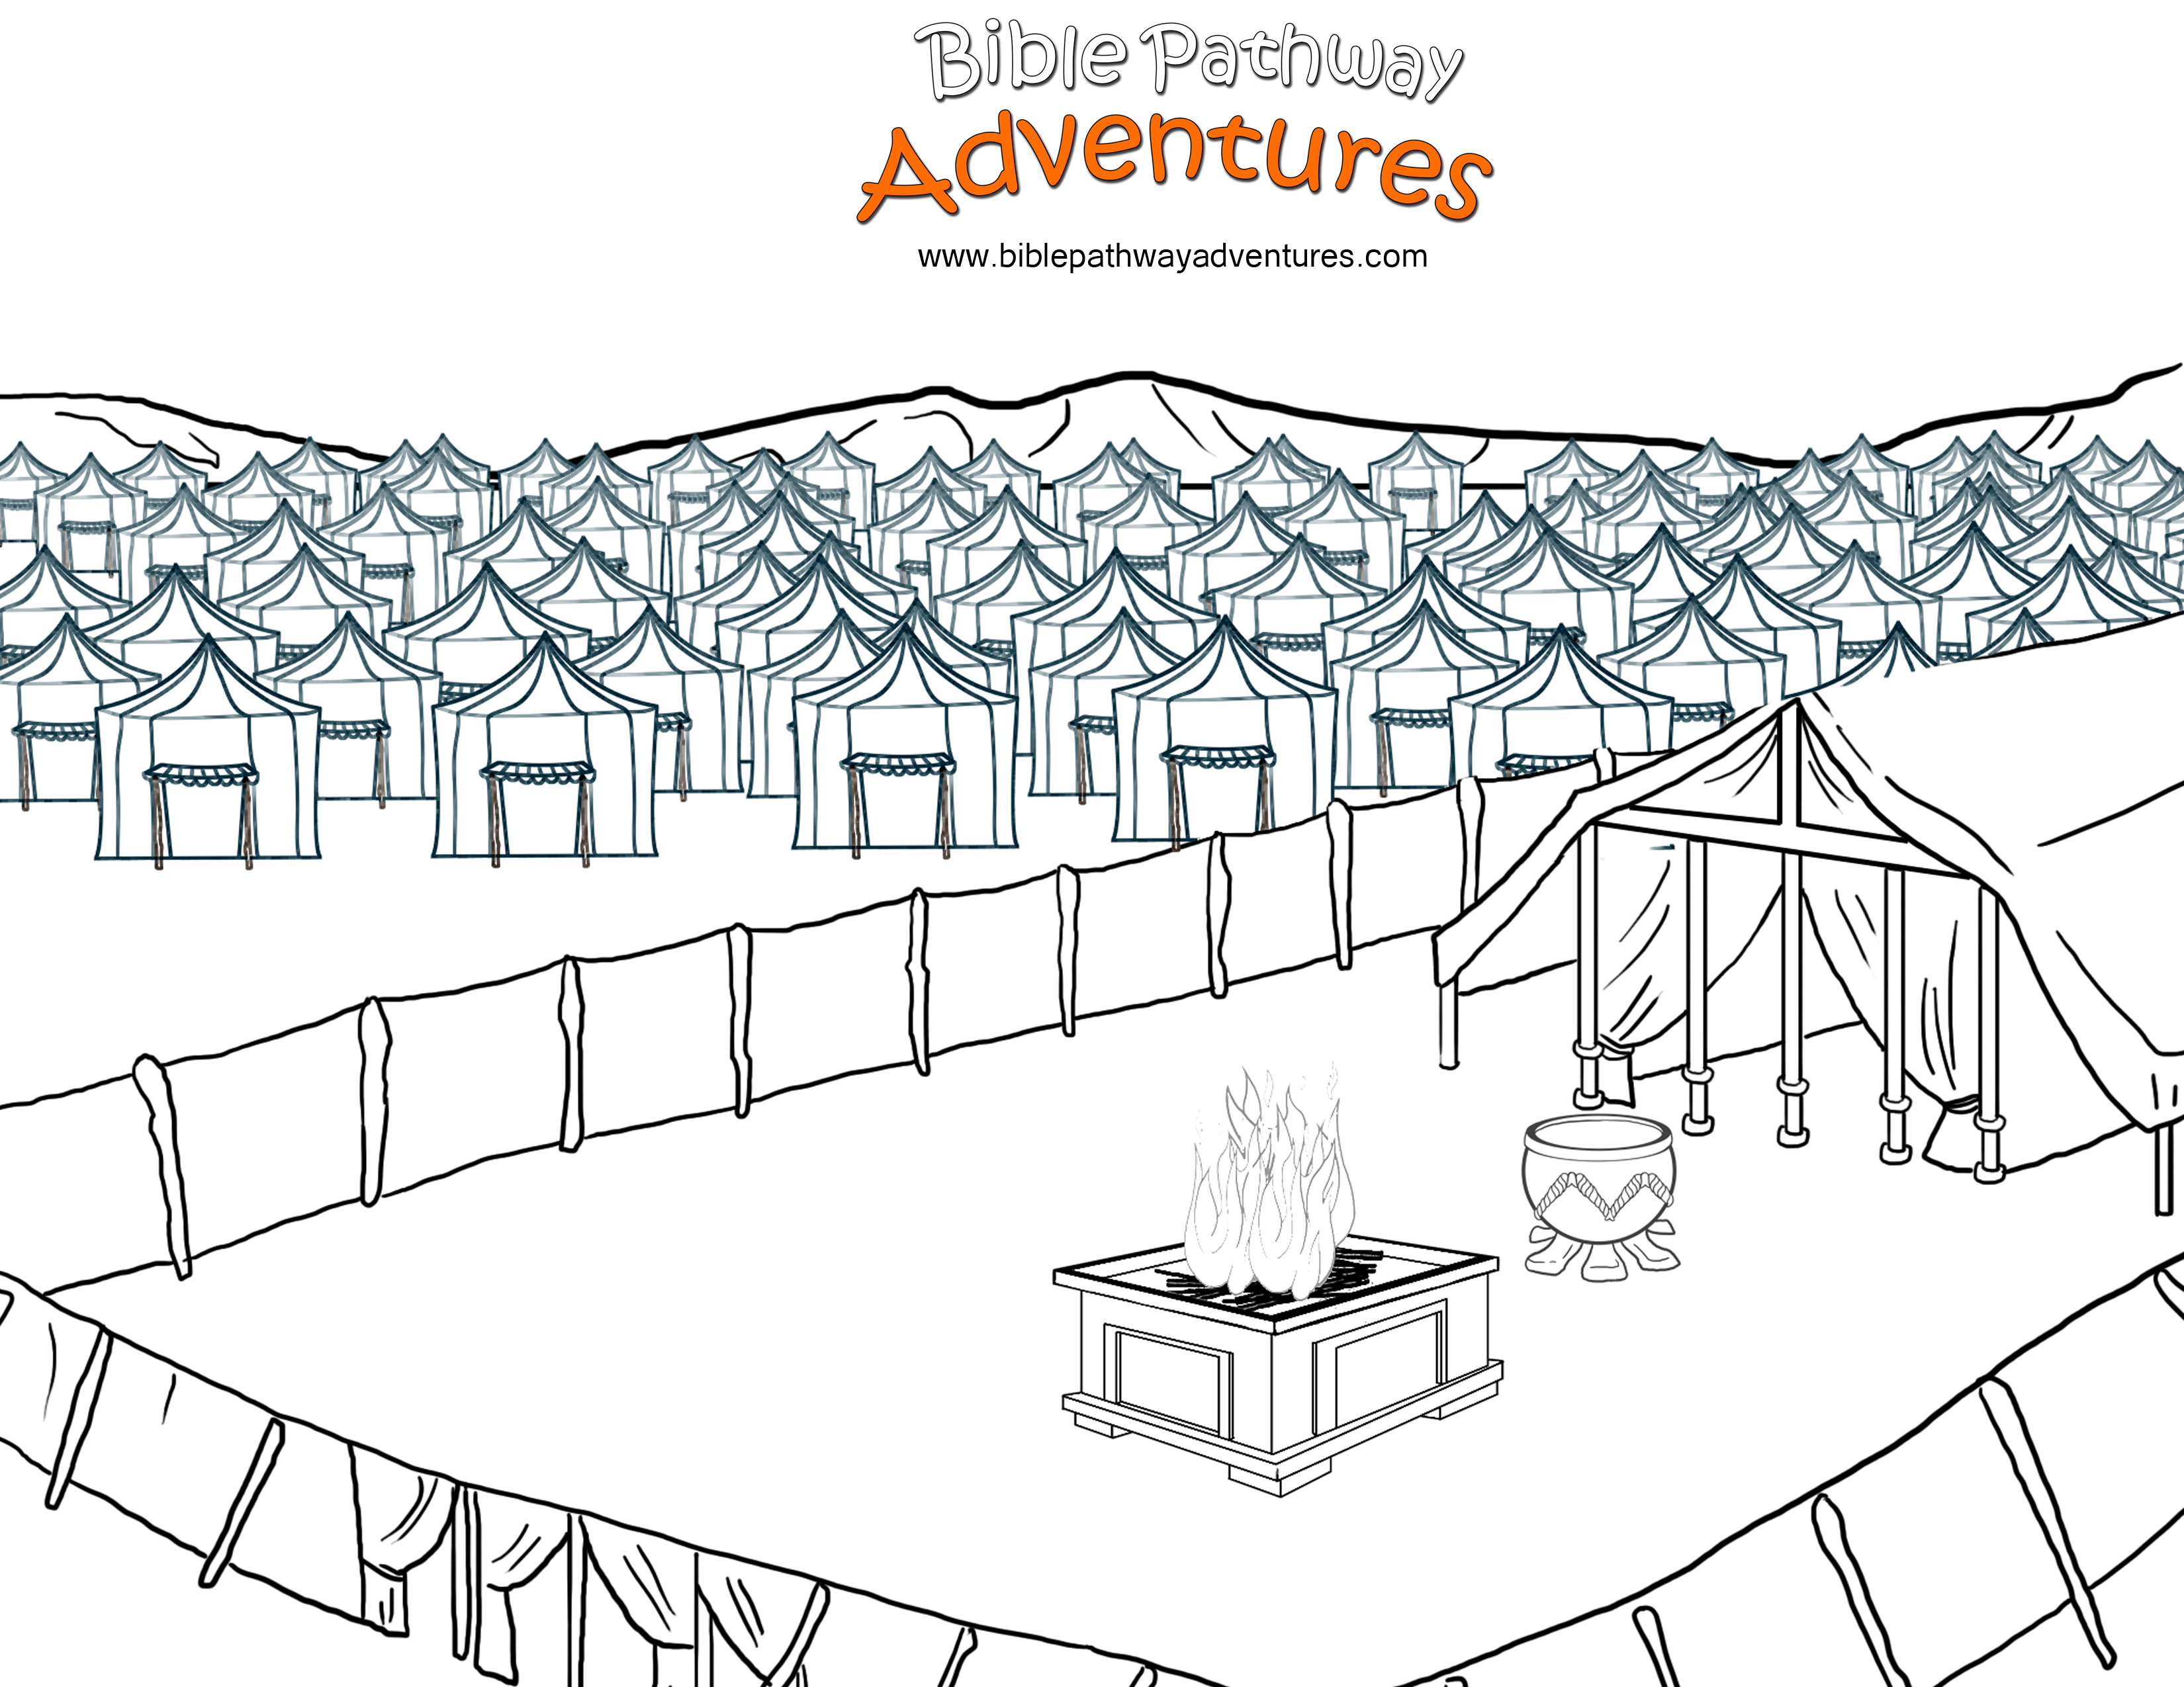

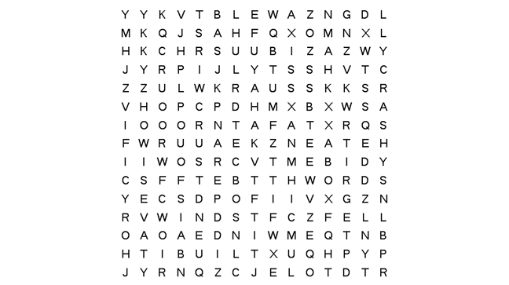

hears built streams foolish

words house winds sand

practice rock blew fell

wise rain foundation crash

The Wise Man and the Foolish Man Word Search